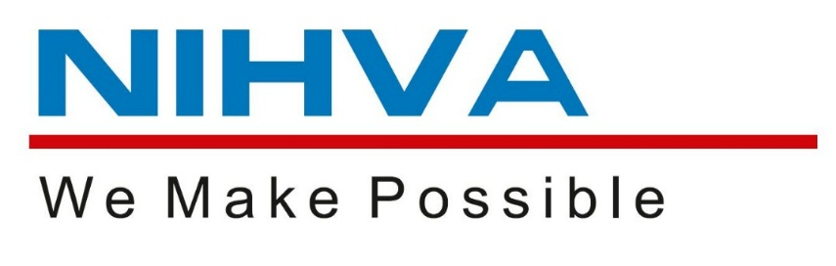

PROJECT: DOCK LEVELER
CLIENT: L&T HYDROCARBON
PROJECT: IOCL
SITE LOCATION: ODISHA
WO NO:

SUPPLY & INSTALLATION BY,

NIHVA TECHNOLOGIES PVT LTD.

G- BLOCK, 1ST FLOOR, THERMAX CHOWK, MIDC, ABOVE RENAULT SHOWROOM, CHINCHWAD, PUNE – 411019.
Email – sales@nihva.com
Web – www.nihva.com
Call - +91 2066 3040 33.

